

**Home task no: 5**

**Name:** Muhammad Mubbashir Khan

**CMS: 465077**

**Sec: (B)**

**Task no: 1**

#include<iostream>

using namespace std;

// Function to calculate HCF of two numbers

int hcf(int a, int b) {

if (b == 0)

return a;

return hcf(b, a % b);

}

// Function to calculate LCM of two numbers

int lcm(int a, int b) {

return (a * b) / hcf(a, b);

}

int main() {

int num1, num2;

cout << "Enter two numbers: ";

cin >> num1 >> num2;

cout << "LCM of " << num1 << " and " << num2 << " is " << lcm(num1, num2);

return 0;

}

**Output:**

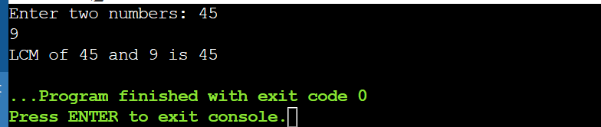

**Task no: 2**

#include<iostream>

using namespace std;

int main() {

int n, a, d;

cout << "Enter the number of terms: ";

cin >> n;

cout << "Enter the first term: ";

cin >> a;

cout << "Enter the common difference: ";

cin >> d;

int sum = (n * (2 * a + (n - 1) * d)) / 2;

cout << "The sum of the arithmetic progression series is: " << sum << endl;

return 0;

}

**Output:**

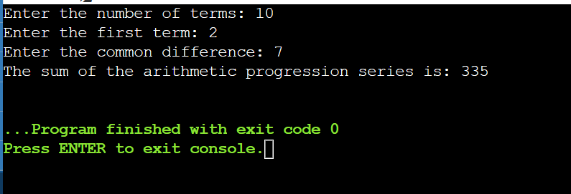

**Task no: 3**

#include <iostream>

using namespace std;

int main() {

int n, i, j, space = 1;

cout << "Enter the number of rows: ";

cin >> n;

space = n - 1;

for (j = 1; j <= n; j++) {

for (i = 1; i <= space; i++)

cout << " ";

space--;

for (i = 1; i <= 2 * j - 1; i++)

cout << "*";

cout << "\n";

}

space = 1;

for (j = 1; j <= n - 1; j++) {

for (i = 1; i <= space; i++)

cout << " ";

space++;

for (i = 1; i <= 2 * (n - j) - 1; i++)

cout << "*";

cout << "\n";

}

return 0;

}

**Output:**

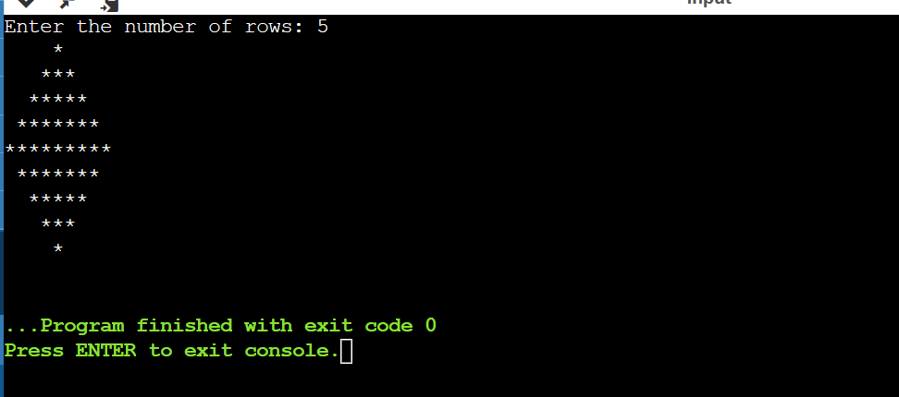

**Task no: 4**

#include<iostream>

using namespace std;

int main() {

int num, binary = 0, i = 1, remainder;

cout << "Enter a decimal number: ";

cin >> num;

while (num != 0) {

remainder = num % 2;

num = num / 2;

binary = binary + (remainder * i);

i = i * 10;

}

cout << "Equivalent binary number: " << binary << endl;

return 0;

}

**Output:**

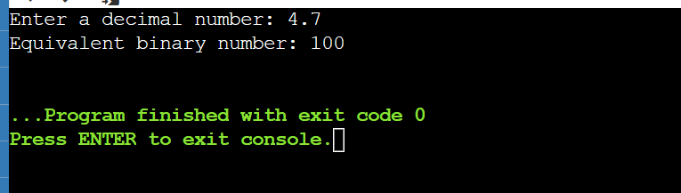

**THE END**